ELECTROSTATICS TEST REVIEW

NAME______________________ DATE___________________

1) Electrically neutral objects cannot exert an electrical force on each other, but they can exert a gravitational force on each other.

A) True

B) False

2) If two objects are electrically attracted to each other,

A) both objects must be negatively charged.

B) both objects must be positively charged.

C) one object must be negatively charged and the other object must be positively charged.

D) the objects could be electrically neutral.

E) None of the above statements are absolutely true.

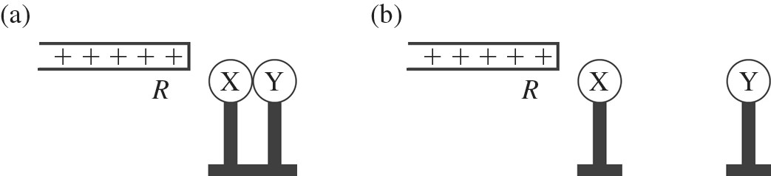

3) X and Y are two initially uncharged metal spheres on insulating stands, and they are in contact with each other. A positively charged rod *R* is brought close to X as shown in part (a) of the figure. Sphere Y is now moved away from X, as shown in part (b). What are the final charge states of X and Y?

A) Both X and Y are neutral.

B) X is positive and Y is neutral.

C) X is neutral and Y is positive.

D) X is negative and Y is positive.

E) Both X and Y are negative.

4) A negatively-charged rod is brought close to (but does not touch) two neutral spheres that are in contact with each other but insulated from the ground. If the two spheres are then separated, what kind of charge will be on the spheres?

A) The sphere near the charged rod becomes positive and the other one becomes negative.

B) The sphere near the charged rod becomes negative and the other one becomes positive.

C) The spheres do not get any charge.

D) Both spheres become negative.

E) Both spheres become positive.

5) Two tiny beads are 25 cm apart with no other charges or fields present. Bead A carries 10 µC of charge and bead B carries 1 µC. Which one of the following statements is true about the magnitudes of the electric forces on these beads?

A) The force on A is 10 times the force on B.

B) The force on B is 10 times the force on A.

C) The force on A is exactly equal to the force on B.

D) The force on A is 100 times the force on B.

E) The force on B is 100 times the force on A.

6) A small charged plastic ball is vertically above another charged small ball in a frictionless test tube as shown in the figure. The balls are in equilibrium a distance *d* apart. If the charge on each ball is doubled, the equilibrium distance between the balls in the test tube would become

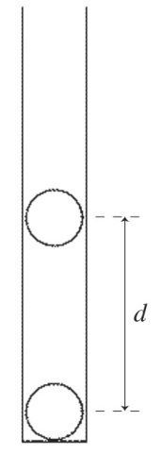

A) *d.*

B) 2*d.*

C) 4*d.*

D) 8*d.*

E) *d*/4.

7) Two identical small charged spheres are a certain distance apart, and each one initially experiences an electrostatic force of magnitude *F* due to the other. With time, charge gradually diminishes on both spheres by leaking off. When each of the spheres has lost half its initial charge, what will be the magnitude of the electrostatic force on each one?

A) 1/16 *F*

B) 1/8 *F*

C) 1/4 *F*

D) 1/2  *F*

E) 1/** *F*

8) Three equal charges +*Q* are at three of the corners of a square of side *d*. A fourth charge +*Q* of equal magnitude is at the center of the square as shown in the figure Which one of the arrows shown represents the net force acting on the charge at the center of the square?

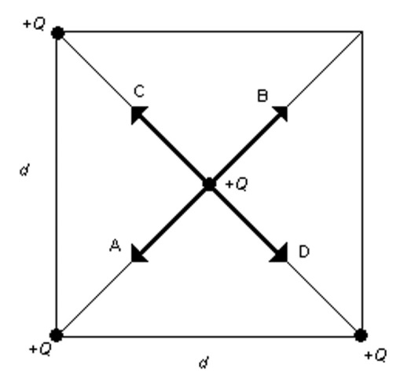

A) A

B) B

C) C

D) D

9) Two small identically charged balls are a certain distance apart. The vectors in the figure show the magnitude and direction of the electrostatic force on each ball due to the other one. Suppose that the charge on the left ball is now doubled (represented by two plus signs). Which vector diagram below best represents the forces that now act on each of the two balls?



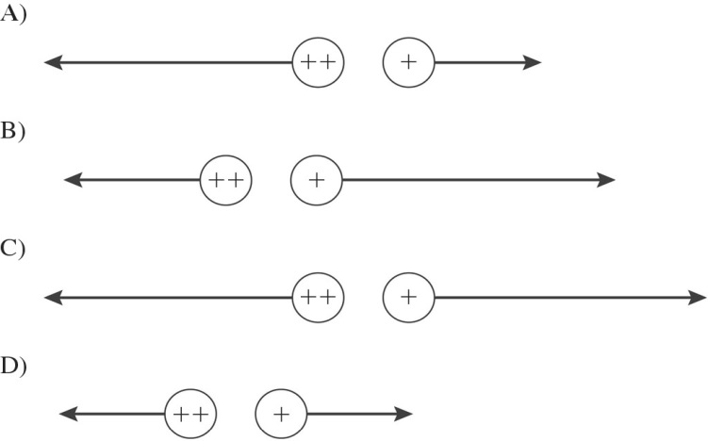

10) Two identical small charged spheres are a certain distance apart, and each one initially experiences an electrostatic force of magnitude *F* due to the other. With time, charge gradually diminishes on both spheres by leaking off. When each of the spheres has lost half its initial charge, what will be the magnitude of the electrostatic force on each one?

A) 1/16 *F*

B) 1/8 *F*

C) 1/4 *F*

D) 1/2  *F*

E) 1/** *F*

11) The force of attraction that a -40.0 μC point charge exerts on a +108 μC point charge has magnitude 4.00 N. How far apart are these two charges? (*k* = 1/4πε0 = 8.99 × 109 N ∙ m2/C2)

A) 2.10 m

B) 3.67 m

C) 3.12 m

D) 2.49 m

E) 1.13 m

12) Two point charges each experience a 1-N electrostatic force when they are 2 cm apart. If they are moved to a new separation of 8 cm, what is the magnitude of the electric force on each of them?

A) 2 N

B) 1/2 N

C) 1/4 N

D) 1/8 N

E) 1/16 N



13) 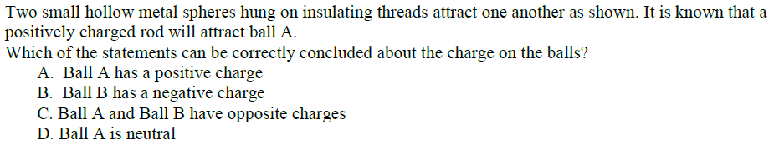

14) 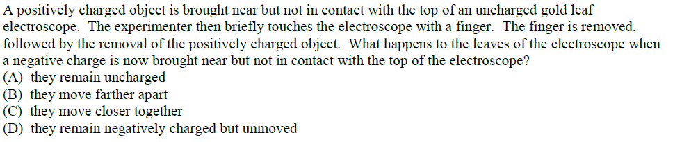

15) 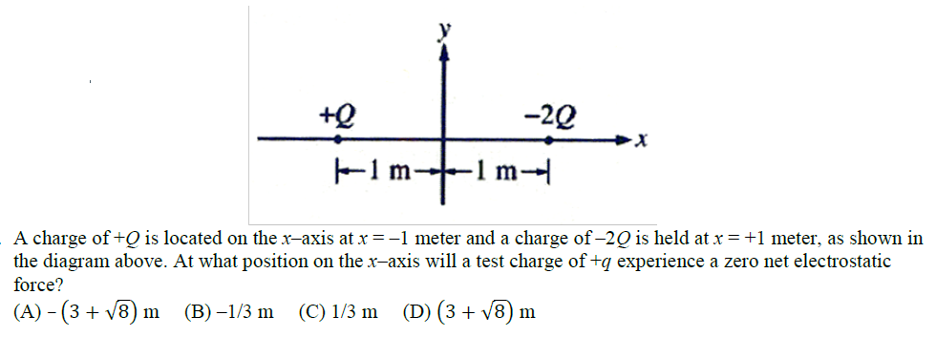

1)B 2) D 3) D 4) A 5) C 6) B 7) C 8) B 9) C 10) C 11) C 12) E 13) D 14) B 15) A