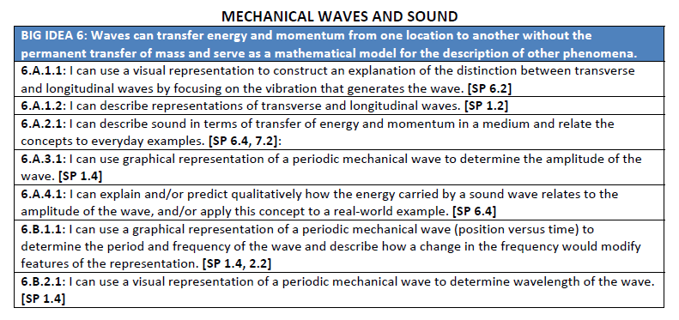
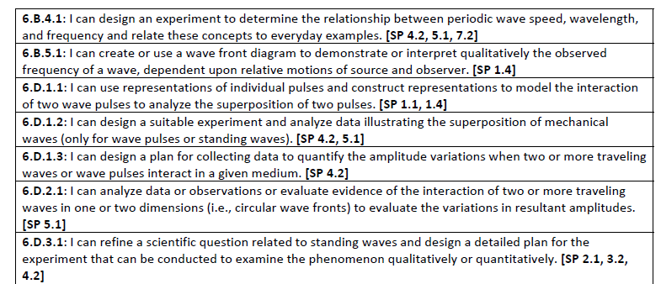
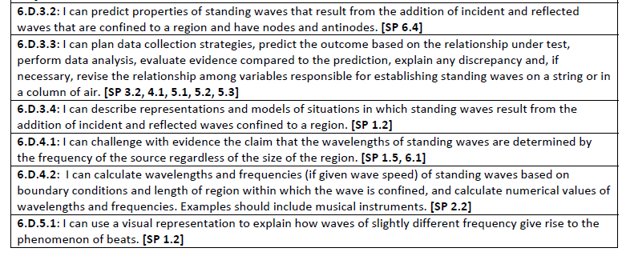

PHYSICS CONCEPTS

WAVES AND SOUND
1. Transverse wave particles vibrate perpendicular to the wave direction and longitudinal wave particles vibrate parallel to the direction of the wave propagation.
2. Sound waves are mechanical longitudinal waves. Light waves are electromagnetic transverse waves.
3. The speed of a wave depends only on the properties of the medium.
4. The energy of a wave is directly proportional to the square of the amplitude.
5. The intensity of sound is inversely proportional to the distance.
6. Superposition Principle: When two or more waves exist simultaneously in the same medium, the resultant amplitude at any point is the algebraic sum of the amplitudes of each wave.
7. The harmonics produced in open pipes are similar to those produced in strings. The fundamental occurs when the length of the pipe (or string) equals (1/2) λ.
8. The fundamental on a closed pope occurs when the length of the pipe equals (1/4) λ. Only the off harmonics are possible for a closed pipe.
9. Whenever two waves exist simultaneously I the same medium and they are nearly at the same frequency, beats are set up.
10. The Doppler Effect is the apparent change in frequency of a source of sound when there is relative motion of the source and the listener.

