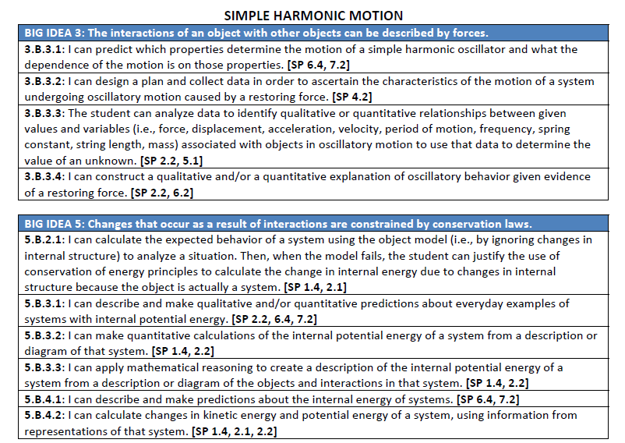

PHYSICS CONCEPTS

OSCILLATIONS
25. Simple harmonic motion is periodic motion in which the restoring force is proportional to the displacement.
26. The maximum displacement of an object from its equilibrium position is the amplitude.
27. At the maximum displacement the object experiences the maximum acceleration and maximum elastic potential energy.
28. At the equilibrium position the object experiences zero acceleration,, maximum velocity and maximum kinetic energy.
29. The period of a pendulum depends on its length and the value of ‘g’ at that particular location.
30. The period of a mass-spring system depends on the mass and the spring constant ‘k’.

