**Name: ________________________________ Period: ______**

**Teacher: _____________________**

**One-Dimensional Motion**

**Unit 1**

**Physics**

**Cedar Ridge HS**

**2017-2018**

Table of Contents

|  |  |
| --- | --- |
| **Topic** | **Page #** |
|  |  |
|  |  |
|  |  |
|  |  |
|  |  |
|  |  |

**My teacher’s website:________________________________________**

**My teacher’s remind info:_____________________________________**

**My teacher’s email:__________________________________________**

Unit 1 Calendar

|  |  |  |  |  |
| --- | --- | --- | --- | --- |
| **Monday** | **Tuesday** | **Wednesday** | **Thursday** | **Friday** |
| Aug 21  No School | 22 A  Welcome to Physics! | 23 B  Welcome to Physics! | 24 A  Introduction to One-Dimensional Motion | 25 B  Introduction to One-Dimensional Motion |
| 28 A | 29 B | 30 A | 31 B | Sep 1 A |
| 4  No School | 5 B | 6 A | 7 B | 8 A |
| 11 B | 12 A | 13 B | 14 A | 15 B |
| 18 A | 19 B | 20 A  Intervention Day | 21 B  Intervention Day | 22 A  **Unit 1 Test** |
| 25 B  **Unit 1 Test** |  |  |  |  |

Unit 1 Learning Outcomes

**Students will know...**

* how to organize data into graphs, charts and equations to represent motion.
* the perceived motion of an object depends on the position and motion of an observer.
* vectors describe and relate an object’s motion mathematically within its frame of reference.
* how to manipulate variables in an equation to represent their mathematical relationship.

Unit 1 Vocabulary

**Vocabulary to review:**

|  |  |  |  |
| --- | --- | --- | --- |
| acceleration accuracy  average  axis  delta **∆**  dimensional analysis | distance  metric units  percent error precision  qualitative data | quantitative data  rate  scale  scientific notation  SI system | significant figures slope  speed  variables  velocity |

**Vocabulary new for mastery:**

|  |  |  |  |
| --- | --- | --- | --- |
| average velocity  direct relationship  (direct variation  used in algebra) displacement  frame of reference | free fall (g)  instantaneous velocity inverse relationship  (inverse variation is  used in algebra) kinematics | linear motion  linear slope magnitude  motion detector  negative acceleration | photogate  positive acceleration resultant  scalar  uniform motion vector |





**Graph Matching**

One of the most effective methods of describing motion is to plot graphs of position, velocity, and acceleration *vs*. time. From such a graphical representation, it is possible to determine in what direction an object is going, how fast it is moving, how far it traveled, and whether it is speeding up or slowing down. In this experiment, you will use a Motion Detector to determine this information by plotting a real time graph of *your* motion as you move across the classroom.

A qualitative analysis of the graphs of your motion will help you understand the concepts of kinematics.

**OBJECTIVES**

Analyze the motion of a student walking across the room.

Predict, sketch, and test position *vs*. time kinematics graphs.

Predict, sketch, and test velocity *vs*. time kinematics graphs.

**MATERIALS**

LabQuest

meter stick

Journal

masking tape

Motion Detector

**PRELIMINARY QUESTIONS**

1. Sketch the position *vs*. time graph for each of the following situations in your journal. Use a coordinate system with the origin at far left and positive distances increasing to the right.

a. An object at rest

b. An object moving in the positive direction (away from the origin) with a constant speed

c. An object moving in the negative direction (towards the origin) with a constant speed

d. An object that is accelerating in the positive direction, starting from rest

2. Sketch the velocity *vs*. time graph for each of the situations described above.

**PROCEDURE**

1. Find an open area at least 4 m long in front of a wall. Use short strips of masking tape on the floor to mark distances of 1 m, 2 m, and 3 m from the wall. You will be measuring distances from the Motion Detector in your hands to the wall.
2. If your Motion Detector has a switch, set it to Normal.



1. Connect the Motion Detector to DIG 1 of LabQuest and choose New from the File menu.
2. On the Meter screen, tap Length, then change the data-collection length to 10 seconds. Select OK.

**Part l Preliminary Experiments**

1. Open the hinge on the Motion Detector. When you collect data, hold the Motion Detector so the round, metal detector is always pointed directly at the wall. Sometimes you will have to walk backwards.



1. Monitor the position readings. Move back and forth and confirm that the values make sense.
2. Make a position *vs* time and velocity *vs* time graph of your motion when you walk away from the wall with a slow constant velocity. To do this, stand about 1 m from the wall and start data collection. Walk backward, slowly away from the wall after data collection begins. Record your graphs on in your journal.
3. Sketch what the graphs will look like if you walk faster. Check your prediction with the Motion Detector. Start data collection when you are ready to begin walking.
4. Test your predictions in the Preliminary Questions section by walking in back and forth in front of the wall. If your predictions of graph shapes were incorrect, draw the correct shape over your prediction in a different color.

**Part Il Position *vs*. Time Graph Matching**

1. Choose Motion Match ► New Position Match from the Analyze menu to set up LabQuest for graph matching. A target graph will be displayed for you to match.
2. In your journal write down how you would walk to reproduce the target graph. Sketch a copy of the graph.
3. To test your prediction, choose a starting position. Start data collection, then walk in such a way that the graph of your motion matches the target graph on the screen.
4. If you were not successful, start data collection again when you are ready to begin walking.
5. Repeat this process until your motion closely matches the graph on the screen. Correct your statement about you would walk to match the graph.
6. Perform a second graph match by again choosing Motion Match ► New Position Match from the Analyze menu. This will generate a new target graph for you to match.
7. Perform a second graph match by again choosing Motion Match ► New Position Match from the Analyze menu. This will generate a new target graph for you to match.
8. Answer the Analysis questions for Part II before proceeding to Part III.
9. Answer the following questions in your journal:
   1. Describe any changes you had to make to your original predictions.
   2. Explain the significance of the slope of a position *vs*. time graph. Include a discussion of positive and negative slope.
   3. What type of motion is occurring when the slope of a position *vs*. time graph is zero?
   4. What type of motion is occurring when the slope of a position *vs*. time graph is constant?
   5. What type of motion is occurring when the slope of a position *vs*. time graph is changing?

**Part IIl Velocity vs. Time Graph Matching**

1. LabQuest can also generate random target velocity graphs for you to match. Choose Motion Match ► New Velocity Match from the Analyze menu to view a velocity target graph.
2. Write down how you would walk to produce this target graph. Sketch or print a copy of the graph.
3. To test your prediction, choose a starting position and stand at that point. Have your partner start data collection, then walk in such a way that the graph of your motion matches the target graph on the screen. It will be more difficult to match the velocity graph than it was for the position graph.
4. If you were not successful, have your partner start data collection when you are ready to start walking. Repeat this process until your motion closely matches the graph on the screen. Print or sketch the graph with your best attempt.
5. Perform a second and third velocity graph match by choosing Motion Match ► New Velocity Match from the Analyze menu. This will generate a new target velocity graph for you to match.
6. Remove the masking tape strips from the floor.
7. Answer the following question in your journal:
8. Describe how you walked for each of the graphs that you matched.
9. What type of motion is occurring when the slope of a velocity *vs*. time graph is zero?
10. What type of motion is occurring when the slope of a velocity *vs*. time graph is not zero?

**EXTENSIONS**

1. Create a graph-matching challenge. Sketch a position *vs*. time graph on a piece of paper and challenge another student in the class to match your graph. Have the other student challenge you in the same way.

2. Create a velocity *vs*. time challenge in a similar manner.

Name_____________________________________________Date__________________Per___

**Graph Matching Lab Results**

Preliminary Questions: Write description and sketch graph.

1a. 2a.

1b. 2b.

1c, 2c.

1d. 2d.

Part 1. Preliminary Experiments

3)

4)

5) use a different color on the graphs in the preliminary questions

Part II. Position vs. Time Graph Matching

2)

5)

6)

9a.

9b.

9c.

9d.

9e.

Part III. Velocity vs. Time Graph Matching

Try this. These graphs may be more difficult to match than the position vs. time graphs.

7b.

7c.

**Moving Man- Distance vs. Time Graphs**

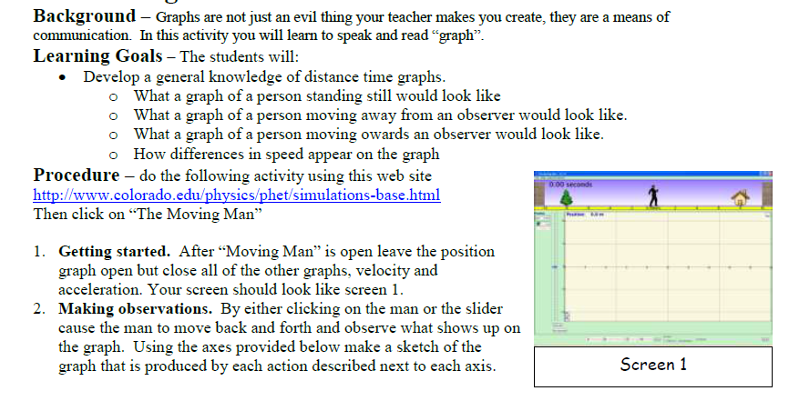

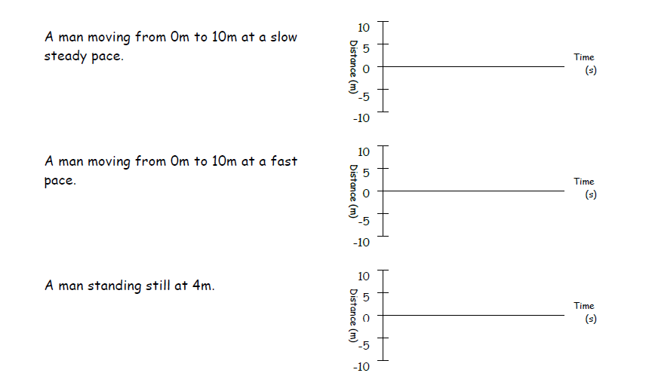

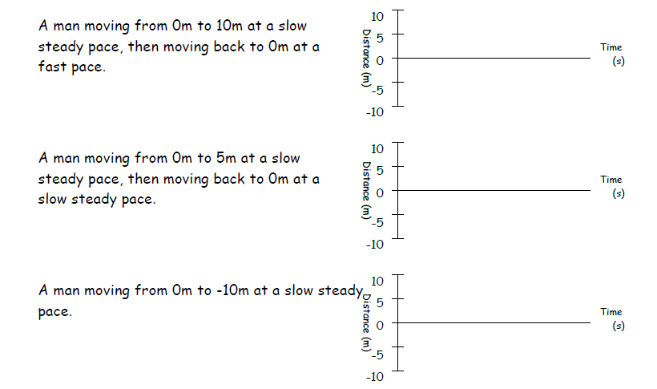

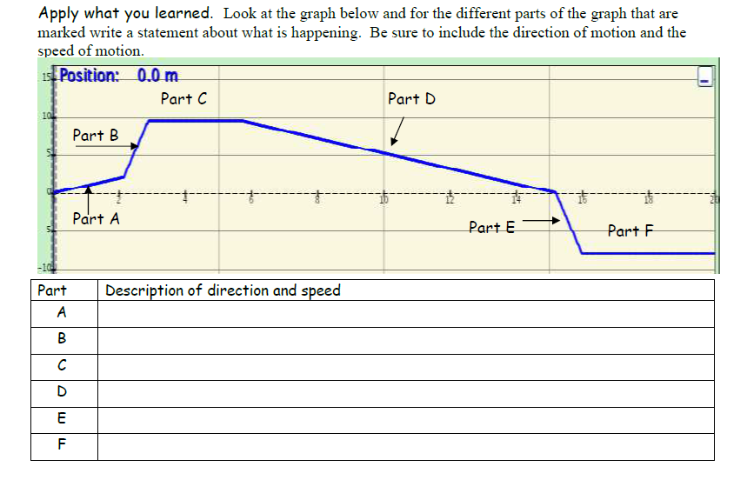

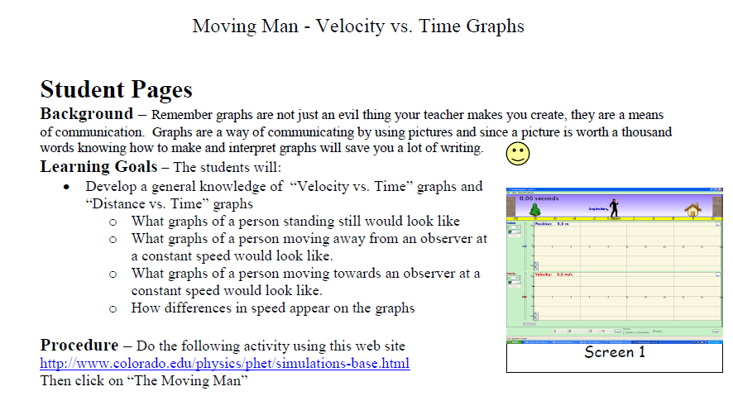

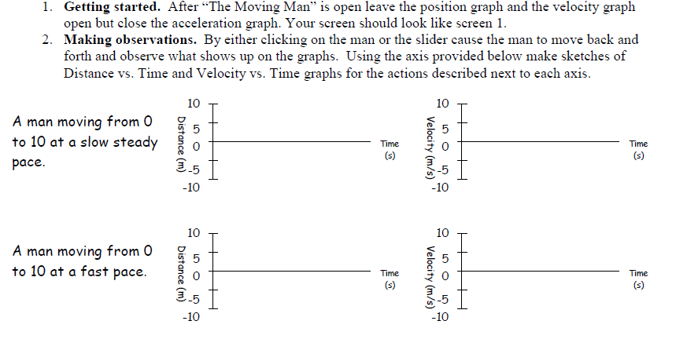

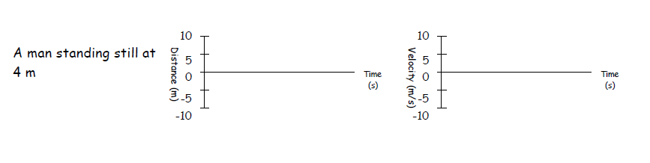

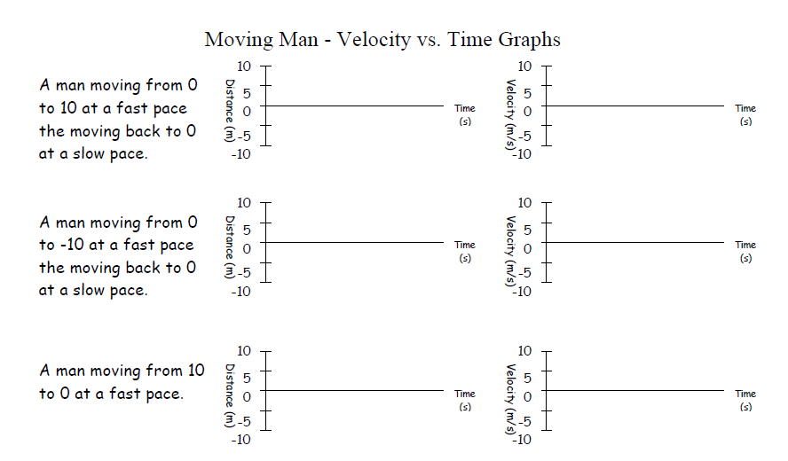

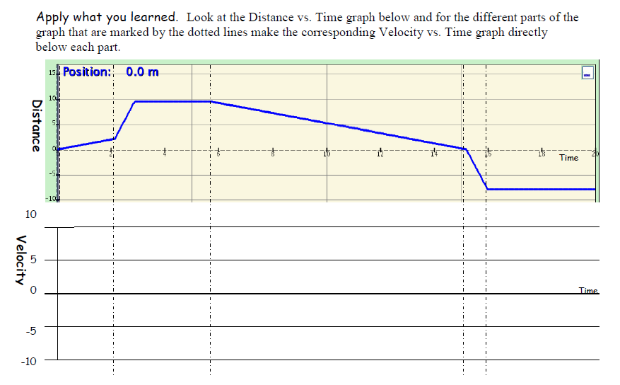

***Project Motion: How Do You Move?***

**Procedure**: Each group will create either a poster, a video, or a skit describing a person’s motion in a school appropriate situation of their choosing. All presentations must include

1. a story describing how someone is moving
   * It must have examples of positive velocity, negative velocity, acceleration, and your person being at rest
2. a Position vs. Time graph that describes your story
3. a Velocity vs. Time graph that describes your story

**Group Roles**: Each group must have a Storyteller, an Artist, and a Grapher.

* The Storyteller will explain the group’s story/graph to the class on presentation day
* The Artist will help create the poster/video/story. A 3 person group must also have:
* A Grapher who will be responsible for drawing the two graphs for the project
  + Any 2-person groups will split the graphing duties

Students may select up to two group members from within their own class period. Group roles will count for 50% of your grade. Please see the attached rubric for a detailed breakdown of the grading.

**Presentation Day**: Each group will present their poster, video, or skit the to their class period. Please see the class calendar on my website for the presentation date.

***Project Motion: How Do You Move? Rubric***

|  | Overall Presentation | Storyteller | Artist | Grapher |
| --- | --- | --- | --- | --- |
| 4 | * Contains both graphs, correctly drawn with slopes properly calculated and used to drawn the VvT graph. * Tells a clear story that is properly matched at all points to your PvT and VvT graphs. * Has clear examples for each of the four types of motion. * Uses physics vocab for all discussion/writing. | * Clearly and specifically describes all of the 4 types of motion and links them to parts in the skit/video/etc. * Identifies the portions of both graphs which match specific pictures/parts of the skit/etc * Correctly uses physics vocab for all of the relevant terms. * Is able to answer all questions | * Clear, correct examples are provided for each of the four types of motion. * The poster/skit/etc… is arranged in a clear, logical order showing how motion changes. * Both graphs are included in the presentation and are large enough to read. | * Both graphs have proper labels for everything. * Both graphs have their lines drawn correctly. * The slopes of the lines on the PvT graph are used to correctly create the VvT graph. |
| 3 | * Contains both graphs, with minor mistakes in drawing the lines/ labeling/ calculating the lines’ slopes correctly/correctly transferring information on PvT graph to Vvt * Tells a story that is, overall, properly matched, at most points, to your PvT and VvT graphs. * Has correct examples for 3 of the 4 types of motion. * Uses physics vocab for most. discussion/writing. | * Correctly describes/identifies 3 of the 4 types of motion in the skit/video/etc, and/or correctly identifies 3 of the 4 portions of both graphs which match specific pictures/parts of the skit/etc * Correctly uses physics vocab for most of the relevant terms. * Is able to answer most questions. | * Correct examples are provided for 3 of the 4 types of motion. * The poster/skit/etc… is arranged in a way that requires a good bit of elaboration to make sense of it. * Both graphs are included in the presentation, but are not large enough to read. | * Both graphs are included with most of the correct labels. * Both graphs have most of their lines drawn correctly. * The slopes of the lines on the PvT graph are used to create an VvT graph, but there are mistakes. |
| 2 | * Contains both graphs, with significant mistakes in drawing the lines/ labeling/ calculating the lines’ slopes correctly/correctly transferring information on PvT graph to VvT * Tells a story that is only partially properly matched to your PvT and VvT graphs. * Has correct examples for 2 of the 4 types of motion. * Uses physics vocab for only a little discussion/writing. | * Correctly describes/identifies 2 of the 4 types of motion in the skit/video/etc, and/or correctly identifies 2 of the 4 portions of both graphs which match specific pictures/parts of the skit/etc * Correctly uses physics vocab only some of the relevant terms. * Is able to answer only some of questions. | * Correct examples are provided for 2 of the 4 types of motion. * The poster/skit/etc… is arranged in a way that requires extreme elaboration to make sense of it. * Only 1 of 2 graphs are included, and it is not large enough to read. | * Both graphs are included with some of the correct labels. * Both graphs have some of their lines drawn correctly. * The slopes of the lines on the PvT graph are used to create an VvT graph, but there are serious mistakes. |
| 1 | * Contains both graphs, with extreme errors in drawing the lines/ labeling/ calculating the lines’ slopes correctly/correctly transferring information on PvT graph to VvT , or is missing one or both graphs * Tells a story that is almost never properly matched to your PvT and VvT graphs. * Has correct examples for 1 or 0 of the four types of motion. * Uses no physics vocab. | * Correctly describes/identifies 1 or fewer of the 4 types of motion in the skit/video/etc, and/or correctly identifies 1 or fewer of the 4 portions of both graphs which match specific pictures/parts of the skit/etc * Uses no physics vocab, or uses it incorrectly. * Is not able to answer questions. | * Correct examples are provided for 1 or fewer of the 4 types of motion. * The poster/skit/etc… is arranged in a way that makes no sense, even with the Storyteller’s elaboration. * No graphs are included. | * One or more graphs are missing and/or one or more graphs is completely lacking correct labels. * Neither graph has any of its lines drawn properly. * The slopes of the lines on the PvT graph are not used to create an VvT graph and/or the translation of PvT to an VvT graph is completely wrong. |

**Motion Graphs**

1. Describe the motion.
2. Sketch the matching velocity vs. time graph.

**Position vs. Time Graphs Velocity vs. Time Graphs**

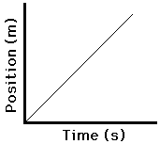

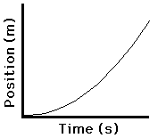

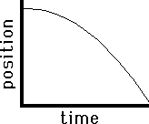

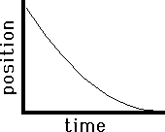

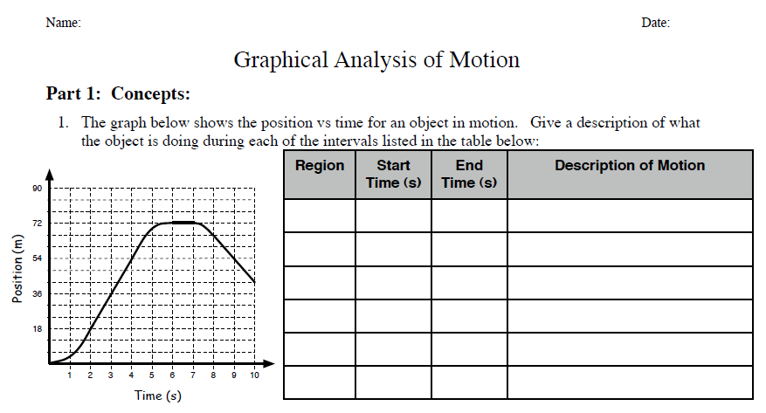

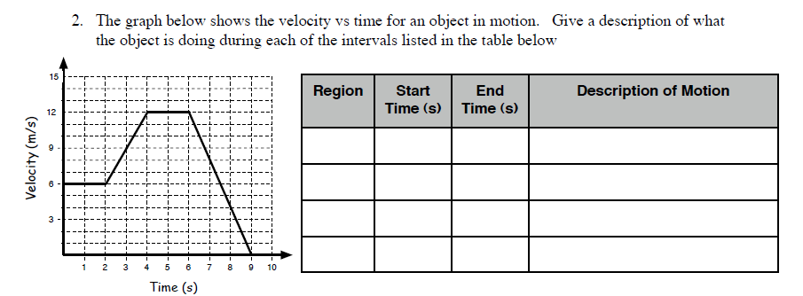

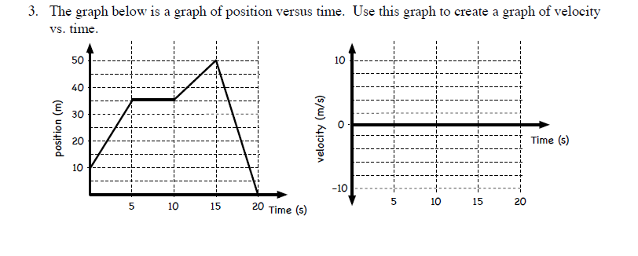

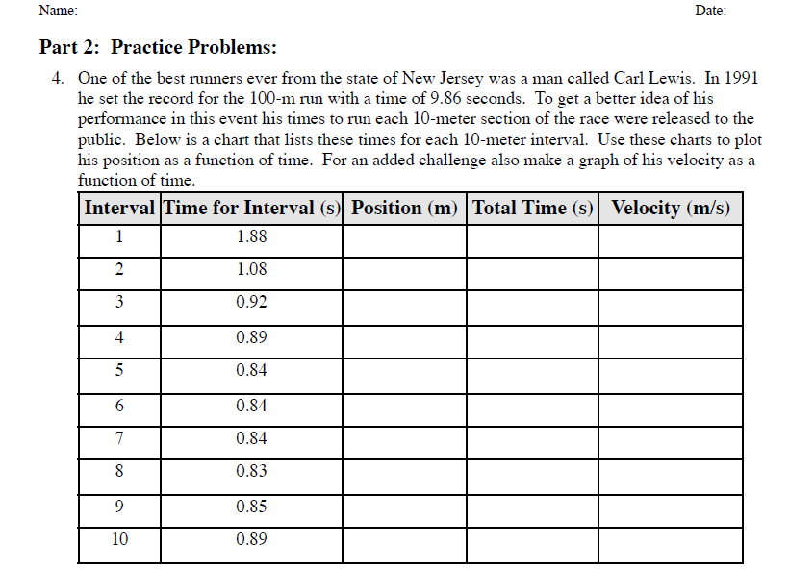

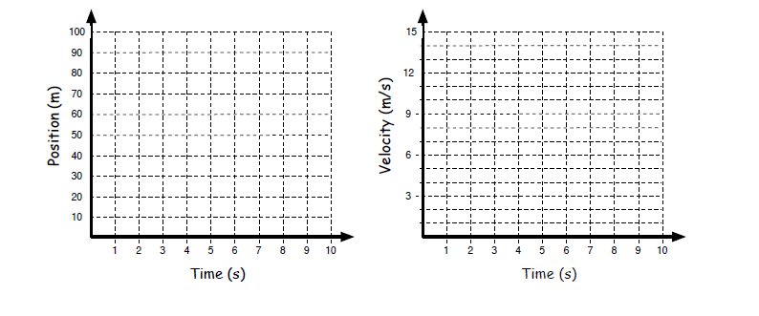

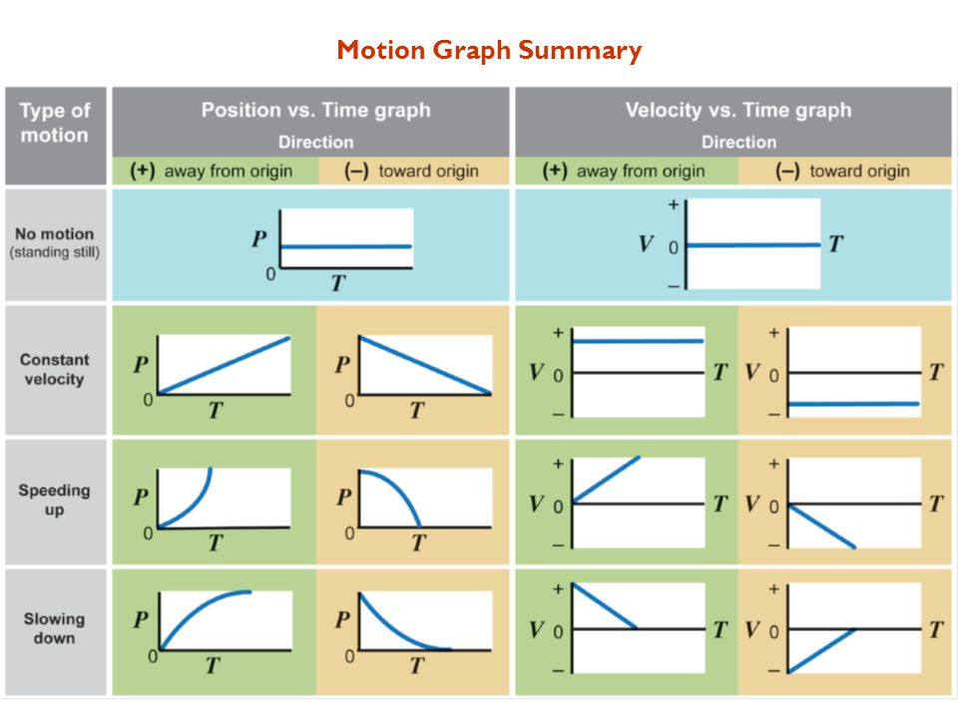

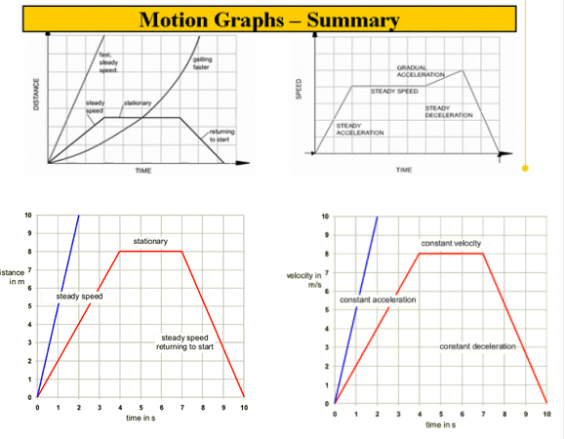

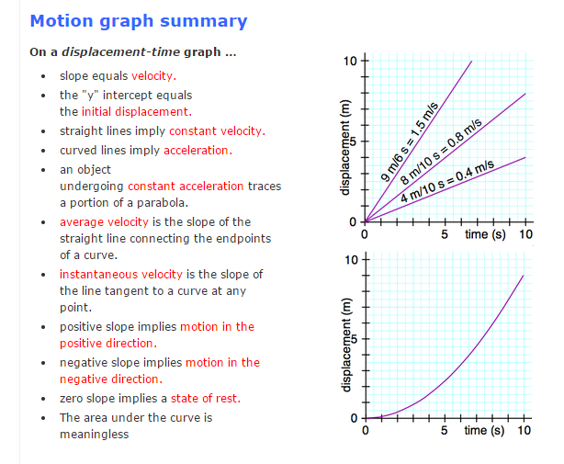

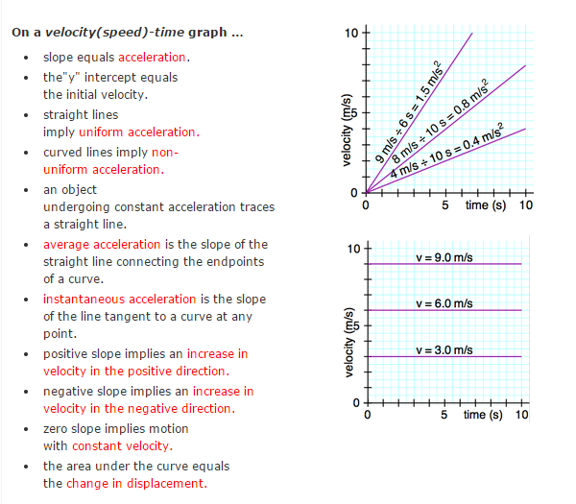



Complete the table by determining the magnitude and direction of the relative velocity of each "object" depicted in the diagram below by comparing each one's motion to the frame of reference listed in the first column of the table.

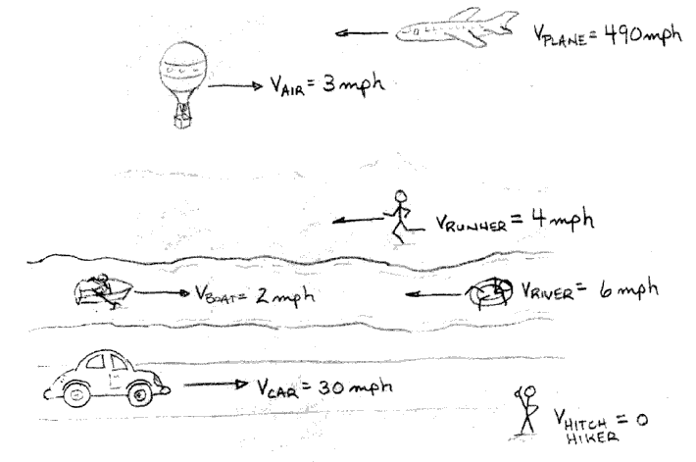

The current values in the table are from the frame of reference of the Hitch Hiker.

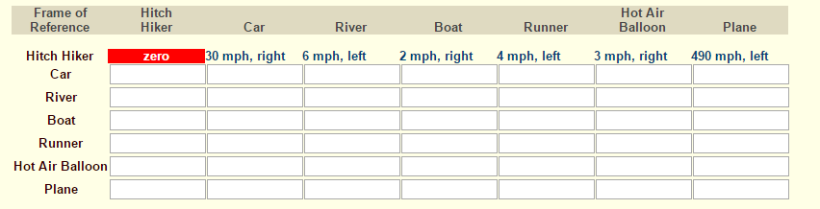

**Formulas Chart**

|  |  |  |  |  |
| --- | --- | --- | --- | --- |
| **1-Dimensional Motion** | | |  | **Other** |
| **Velocity** | **Acceleration** | | **Gravity**  g = 9.8 m/s2  **Pythagorean**  a2 + b2 = c2 |
|  |  |

**Quantity Chart**

|  |  |  |  |  |
| --- | --- | --- | --- | --- |
| **Quantity** | **Symbol in Formula** | **Description/ definition** | **Unit** | **Unit Symbol** |
| distance |  |  |  |  |
| displacement |  |  |  |  |
| speed |  |  |  |  |
| velocity |  |  |  |  |
| acceleration |  |  |  |  |
| acceleration due to gravity |  |  |  |  |
| time |  |  |  |  |

Name: Period:   
  
**One-Dimensional Motion Practice Problems**

1) A bird that is traveling at 5 m/s, accelerates at 2.5 m/s2 for 8 seconds. How far did the bird travel during those 8 seconds?

2) A race car that is traveling at 45 m/s, accelerates at 9 m/s2 for 12 seconds. How far did the car travel during those 12 seconds?



3) A lion is chasing a zebra at 4 m/s. The lion accelerates at a rate of 1.3 m/s2 for 23 seconds. How far did the lion travel during those 23 seconds?



4) A bus that is traveling at 15 m/s accelerates at a rate of 3.3 m/s2 for 6 seconds. How far did the bus travel during those 6 seconds?



5) A fighter jet is traveling at 300 m/s, and accelerates at 30 m/s2 for 21 seconds. How far did the jet travel during those 21 seconds?



6) A bicycle that is traveling at 2 m/s accelerates at 1.2 m/s2 for 13 seconds. How far did the bike travel during those 13 seconds?

7) A car is initially traveling at a speed of 32 meters per second. Its breaks are applied over a distance of 45 meters, causing it to accelerate to a speed of 12 meters per second. What is the magnitude of the car’s acceleration?

8) An elephant is initially traveling at a speed of 2 meters per second. It sees a mouse, and runs away for 45 meters, causing it to accelerate to a speed of 12 meters per second. What is the elephant’s acceleration?

9) A car is initially traveling at a speed of 22 meters per second. Its driver stomps on the gas pedal and keeps it pressed down to the floor, over a distance of 115 meters, causing it to accelerate to a speed of 35 meters per second. What is car’s acceleration?

10) A cat is initially traveling at a speed of 1.5 m/s. It sees a mouse, and chases it for 12 meters, reaching a top speed of 12 m/s. What is the cat’s acceleration?



11) A dog is at rest, and sees the cat from problem 10. The dog chases the cat back to the cat’s home, 45 meters away. The dog’s top speed is while chasing the cat is 9 m/s, towards the cat’s home. What is the dog’s acceleration?

12) The Flash is running at a speed of 500 m/s. He slips on a banana peel, and then tumbles over 275 meters of sandpaper, causing the Flash to accelerate to a speed of 2 m/s. What is the Flash’s acceleration?

13) A flying fish is swimming at 3 m/s, and leaps out of the water, traveling 11 m/s. If it took the fish .4 seconds to jump out of the water, what was the fish’s acceleration?

14) An Olympic skier is competing in the super giant slalom, and reaches a speed of 40 m/s at the bottom of the hill. In 4.2 seconds, he comes to rest. What is the skier’s acceleration?



15) Dorothy is walking through the forest at a rate of 1.3 m/s, when she is captured by a flying monkey. The monkey flies off at 15.5 m/s. It took the monkey 2 seconds to reach its top speed. What was the flying monkey’s acceleration?

16) The driver of a sports car is driving at 5 m/s when he takes the on-ramp for the toll road. After 11 seconds, his velocity is 37 m/s. What is the driver’s acceleration?

17) A Great White shark is chasing a seal through the water at 15 m/s, and accelerates to a speed of 26 m/s in 2 seconds, before eating the seal. What is the shark’s acceleration?



18) A giant squid then sees the shark from problem 17, and swims up to the surface at 3 m/s, before grabbing the shark, and dragging it down into the deep at a speed of 40 m/s. It takes the squid 16 seconds to reach the bottom of the ocean. What was the squid’s acceleration?

### Example 1 - Vectors

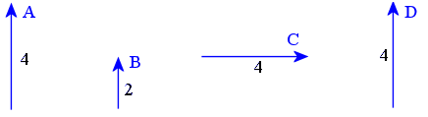

The displacement vector **A** has direction 'up' and a magnitude of 4 cm.

Vector **B** has the same direction as **A**, and has half the magnitude (2 cm).

Vector **C** has the same magnitude as **A**(4 units), but it has different **direction**.

Vector **D** is equivalent to vector **A**. It has the same magnitude and the same direction. It doesn't matter that **A** is in a different position to **D** - they are still considered to be **equivalent vectors** because they have the same magnitude and same direction. We can write:

**A** = **D**

**Note:**We **cannot** write **A = C** because even though **A** and **C** have the same magnitude (4 cm), they have different direction. They are not equivalent.

**Practice Problems. Find the magnitude and direction. Draw the vectors to scale and label the vectors and the resultant.**

1. **A + B 2. A + C 3. A + D 4. B + C 5. B + D 6. A + B + C**

**Toy Car Lab**

**Investigating:**

1. What is the effect of time on the distance traveled by the toy car?
2. Is velocity constant for each car?

**Brainstorm**

1. What is the independent variable? What should be the increments? How many times?
2. What is the dependent variable? (This is what’s measured!)

**Data Table and Graph Build**

**Results**

* Develop a procedure, grab a car, collect – analyze – graph data.
* Please only take one type of car at once. When you are finished, return the car so another group can use it.
* Turn the car off when not being used to conserve batteries.

**Toy Car Lab**

**Purpose:**

The purpose of this lab is to determine the effect of time on the distance traveled by a toy car.

**Materials:** (list the materials used)

**Procedure:** (number the steps used to perform the lab)

1.

2.

3.

4.

**Data:**

|  |  |  |  |
| --- | --- | --- | --- |
| **TRIAL**  **(car 1)** |  |  |  |
| 1 |  |  |  |
| 2 |  |  |  |
| 3 |  |  |  |

|  |  |  |  |
| --- | --- | --- | --- |
| **TRIAL**  **(car 2)** |  |  |  |
| 1 |  |  |  |
| 2 |  |  |  |
| 3 |  |  |  |

**Graph:** (remember to title and label axes with units)

|  |  |  |  |  |  |  |  |  |  |  |  |  |  |  |
| --- | --- | --- | --- | --- | --- | --- | --- | --- | --- | --- | --- | --- | --- | --- |
|  |  |  |  |  |  |  |  |  |  |  |  |  |  |  |
|  |  |  |  |  |  |  |  |  |  |  |  |  |  |  |
|  |  |  |  |  |  |  |  |  |  |  |  |  |  |  |
|  |  |  |  |  |  |  |  |  |  |  |  |  |  |  |
|  |  |  |  |  |  |  |  |  |  |  |  |  |  |  |
|  |  |  |  |  |  |  |  |  |  |  |  |  |  |  |
|  |  |  |  |  |  |  |  |  |  |  |  |  |  |  |
|  |  |  |  |  |  |  |  |  |  |  |  |  |  |  |
|  |  |  |  |  |  |  |  |  |  |  |  |  |  |  |
|  |  |  |  |  |  |  |  |  |  |  |  |  |  |  |
|  |  |  |  |  |  |  |  |  |  |  |  |  |  |  |
|  |  |  |  |  |  |  |  |  |  |  |  |  |  |  |
|  |  |  |  |  |  |  |  |  |  |  |  |  |  |  |
|  |  |  |  |  |  |  |  |  |  |  |  |  |  |  |
|  |  |  |  |  |  |  |  |  |  |  |  |  |  |  |

**Conclusion Questions:**

1. What is the effect of time on the distance traveled by the toy car?
2. Is velocity constant for each car?

Name_______________________________________________Date______________________Per___

**Free-Fall Lab**

**Scenario:**

A group of young enterprising students at Cedar Ridge HS used three different heights around the campus and timed how long it took a tennis ball to fall to the ground.

**Procedure**: **(**write your procedure below**)**








**Data**:

|  |  |  |  |  |  |
| --- | --- | --- | --- | --- | --- |
| Height (m) | Trial 1 (s) | Trial 2 (s) | Trial 3 (s) | Average (s) | g (m/s2) |
|  |  |  |  |  |  |
|  |  |  |  |  |  |
|  |  |  |  |  |  |

**Conclusion:**

1. According to the data, what is the best known value for baby g here at CRHS?
2. Why does this value not match the accepted 9.8 m/s2?
3. Is there a relationship between the height used and how accurate baby g was found to be?
4. Where there any data points that should have been thrown out? Why?

Name ____________________________________Date___________________Period ___

**Free Fall Problems Worksheet**

For the following problems, show all work and write the answers in the blank.

1. An object falls from a high building. Ignoring air resistance, what will its velocity be after 6 seconds of falling?

________________

2. An object falls from a high building and hits the ground in 9.0 seconds. Ignoring air resistance, what is the distance that it fell?

________________

3. During a tornado in 2008 the Peachtree Plaza Westin Hotel in downtown Atlanta suffered damage. Suppose a piece of glass dropped near the top of the hotel falling 215 meters.

A. Ignoring air resistance, how long would it take the piece of glass to hit the ground?

________________

B. Ignoring air resistance, what will the velocity of the piece of glass be when it strikes the

ground?

________________

4. An object falls from the Transco Tower in Houston and takes 15 seconds to reach the ground.

A. What is its velocity at impact if air resistance is ignored?

________________

B. How tall is the building?

________________

C. What is its acceleration at the 2nd second?

_______________

D. What is its acceleration at the 5th second?

_______________

E. If the Transco Tower were actually 3,000 meters tall, how long would an object take to free-fall off of the top of the building? (ignoring air resistance)

________________

5. Wil-E-Coyote drops a bowling ball off a cliff to try to catch the Roadrunner. The cliff is 132m high.

A. How long does it take the ball to fall to the ground?

_________________

B. What is its impact velocity?

_________________

C. How far does it fall in the first 3.0 seconds?

_________________

D. How fast is it going at the end of 3.0 seconds?

_________________

E. How long would it take the same ball to fall if the cliff was on the moon?

(g = 1.63 m/s2)?

_________________

6. You drop your cell phone while in the bathroom in front of the mirror while the water is running in the sink below. If you are 0.45 meters above the sink, how long do you have before your cell phone is a gonner.

_________________

**One Dimensional Motion Study Guide**

**Speed and Velocity**

_____ Calculate speed or velocity when given distance and time.

_____Calculate distance when given speed or velocity and time.

**Vectors**

_____Add two vectors that go in the same direction.

_____Add two vectors that go in opposite directions.

_____Add two vectors that are perpendicular.

_____Add more than two vectors and resolve the resultant vector.

_____Understand the difference between distance and displacement.

_____Understand the difference between speed and velocity.

**Motion Graphs**

_____Interpret an object moving at constant positive velocity off of a position time graph.

_____Interpret an object moving at constant negative velocity off of a position time graph.

_____Interpret an object at rest off of a position time graph.

_____Interpret an object speeding up (accelerating) off of a position time graph.

_____Interpret an object slowing down (accelerating) off of a position time graph.

_____Interpret an object at rest off of a velocity time graph.

_____Interpret an object moving at constant positive velocity off of a velocity time graph.

_____Interpret an object moving at constant negative velocity off of a velocity time graph.

_____Interpret an object with positive acceleration off of a velocity time graph.

_____Interpret an object with negative acceleration off of a velocity time graph.

_____Draw and identify the distance time graph of an object experiencing free-fall.

_____Draw and identify the speed time graph of an object experiencing free-fall.

**Horizontal Acceleration**

_____Identify hidden variables such as from rest or to a stop.

_____Identify the variables of distance, time, initial speed/velocity, final speed/velocity and acceleration in word problems.

_____Recognize acceleration when given data tables of time and displacement.

_____Solve for final speed/velocity when given initial speed/velocity, time and acceleration.

_____Solve for distance when given acceleration, initial and final speed/velocity.

_____Solve for distance when given acceleration, initial and final speed/velocity.

_____Solve for acceleration when give distance, initial and final speed/velocity.

_____Solve for acceleration when give time, initial and final speed/velocity.

_____Solve for distance when give time, initial speed/velocity and acceleration.

**Vertical Acceleration**

_____Identify hidden variables such as initial velocity when dropped, velocity at the apex, and acceleration due to gravity.

_____Identify the variables of distance, time, initial speed/velocity, final speed/velocity and acceleration in word problems.

_____Understand why acceleration due to gravity is negative.

_____Understand why displacement of a falling object is negative.

_____Solve for acceleration due to gravity when given displacement, initial and final speed/velocity.

_____Solve for the height of a dropped object when given time.

_____Solve for final velocity of a dropped object when given time.