Name: _____________________________________ Period: __8____

Teacher: ISOKPUNWU

Work, Power
and Energy
Unit Packet
Unit 6

Physics
Cedar Ridge HS
2016-2017

Table of Contents
Topic | Page #
Work
Power
Energy
Conservation of Energy
Work-Energy Theorem
Unit 6 Test Review

My teacher’s website:________________________________________
My teacher’s remind info:_____________________________________
My teacher’s email:__________________________________________

Online Textbook: my.hrw.com
- Usernames are RRISDs+ 6 Digit Student ID #
- Example: RRISDs123456
- Passwords are all s+ 6 Digit Student ID #
- Example: s123456

Unit 6 Calendar
Monday | Tuesday | Wednesday | Thursday | Friday
2  No School | 3 A  Introduction to Work and Power | 4 B  Introduction to Work and Power | 5 A | 6 B
9 A | 10 B | 11 A | 12 B | 13 A
16  No School | 17 B | 18 A | 19 B | 20 A
23 B | 24 A  Unit 6 Quiz | 25 B  Unit 6 Quiz | 26 A  Intervention Review Day | 27 B  Intervention  Review Day
30 A  Unit 6 Test | 31 B  Unit 6 Test

Unit 6 Learning Outcomes
Students will know...
- Systems in the natural world conserve mechanical energy.
- Energy occurs in many forms.
- The amount of work done is equal to the change in mechanical energy.
- Total mechanical energy is the sum of potential energy, kinetic energy and work done on the object.
- As energy transforms from one form to another, it is neither created nor destroyed.
- When an object moves in the direction of an applied force, mechanical work is done.
- Power is the rate at which energy is transformed.
1-Dimensional Motion |  |  |  | Other
Velocity  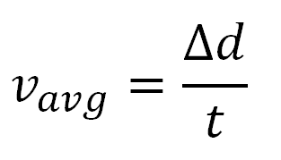  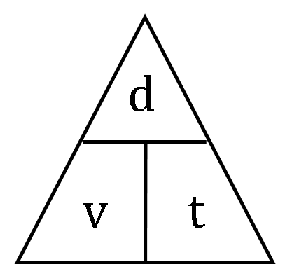 | Acceleration |  |  | Gravity  g = 9.8 m/s²  Pythagorean  a² + b² = c²
 | 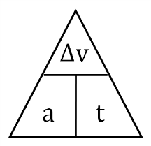  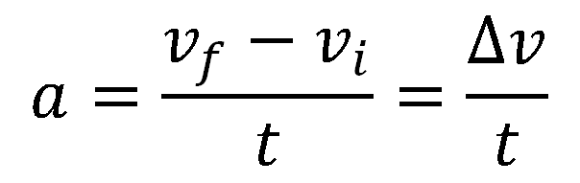 | 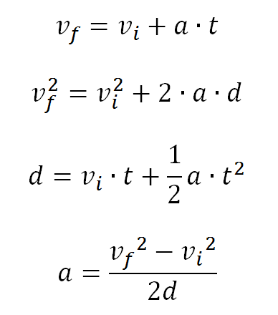

2-Dimensional Motion |  | Solving 2 Dimensional Motion
Horizontal Motion  Vertical Motion  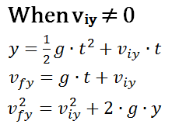 |  | Horizontal Vertical  x = ? y = ?  v_{x} = ? v_{y} = 0 m/s  a_{x} = 0 m/s² a_{y} = 9.8 m/s²  t = ?

Forces |  |  |  | Momentum and Impulse
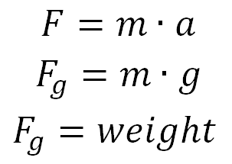  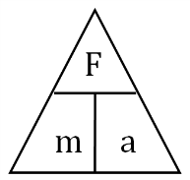 |  |  |  | 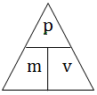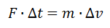  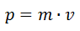 |  |  |  | 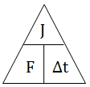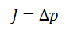  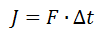
Elastic Collision: $\left(m_{1}v_{1i}\right)+\left(m_{2}v_{2i}\right)=\left(m_{1}v_{1f}\right)+\left(m_{2}v_{2f}\right)$

Inelastic Collision: ${ \left(m_{1}v_{1i}\right)+\left(m_{2}v_{2i}\right)}_{}={(m_{1}+m}_{2})v_{f}$

Recoil: $0=m_{1}v_{1f}+m_{2}v_{2f}$
Rotation Motion
Work - Power – Energy
Electrostatics |  |  |  |  | Waves and Light
$$F_{e}=k_{c}\frac{q_{1}q_{2}}{d^{2}}$$

$$k_{c}=8.99 x{10}^{9}\frac{N∙m^{2}}{C^{2}}$$
Gravitation Force
Circuits
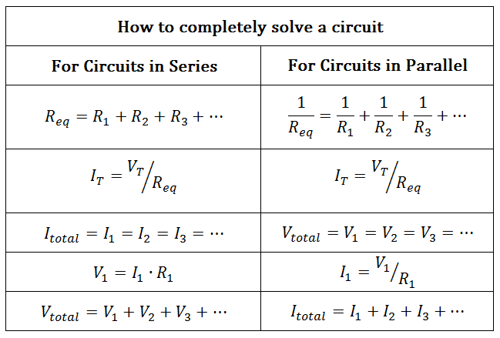
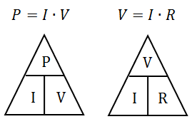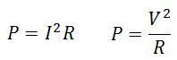

Unit 6 Vocabulary
Work - the product of the component of a force along the direction of displacement and the magnitude of displacement
Power - a quantity that measures the rate at which work is done or the rate of energy transfer by any method
Energy - the ability to perform work
Kinetic Energy - the energy of an object that is associated with the object’s motion
Work-Kinetic Energy Theorem - the net work done by all the forces acting on an object is equal to the change in the object’s kinetic energy
Unit 6 Vocabulary
Gravitational Potential Energy - the energy associated with an object due to the object’s position relative to a gravitational source
Elastic Potential Energy - the energy stored in any deformed elastic object, such as a compressed spring or stretched rubber band
Mechanical Energy - the sum of kinetic energy and all forms of potential energy
Displacement - the change in position of an object
Force - an action exerted on an object that may change the object’s state of rest or motion; force has as magnitude and direction
Work
When a force acts upon an object to cause a displacement of the object, it is said that work was done upon the object. There are three key ingredients to work - force, displacement, and cause. In order for a force to qualify as having done work on an object, there must be a displacement and the force must cause the displacement. There are several good examples of work that can be observed in everyday life - a horse pulling a plow through the field, a father pushing a grocery cart down the aisle of a grocery store, a freshman lifting a backpack full of books upon her shoulder, a weightlifter lifting a barbell above his head, an Olympian launching the shot-put, etc. In each case described here there is a force exerted upon an object to cause that object to be displaced.

To Do Work, Forces Must Cause Displacements

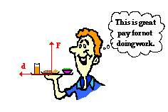
It can be accurately noted that the waiter's hand did push forward on the tray for a brief period of time to accelerate it from rest to a final walking speed. But once up to speed, the tray will stay in its straight-line motion at a constant speed without a forward force. And if the only force exerted upon the tray during the constant speed stage of its motion is upward, then no work is done upon the tray. Again, a vertical force does not do work on a horizontally displaced object.

The Meaning of Negative Work
On occasion, a force acts upon a moving object to hinder a displacement. Examples might include a car skidding to a stop on a roadway surface or a baseball runner sliding to a stop on the infield dirt. In such instances, the force acts in the direction opposite the objects motion in order to slow it down. The force doesn't cause the displacement but rather hinders it. These situations involve what is commonly called negative work.

Reading Comprehension:

- What are the three key ingredients for it to be said work was done?
- Why is carrying a tray not considered work in the physics sense?
- What types of scenarios have negative work?
Work Notes
Work Practice
1. Calculate the amount of work done when moving a 567 N crate a distance of 20 m.

2. A fallen tree with a weight of 100 N is lifted 2.75 meters. How much work is done?

3. If it took a bulldozer 567.6 J of work to push a mound of dirt 30.5 m, how much force did the bulldozer have to apply?

4. A frontend loader needed to apply 137 N of force to lift a rock. A total of 223 J of work was done. How far was the rock lifted?

5. A young boy applied a force of 2,550 N on his St. Bernard dog who is sitting on the boy's tennis shoes. He was unable to move the dog. How much work did he do trying to push the dog?

6. If it takes 68 J of work to push a desk chair 2.5 m across a floor, what force would be needed?

7. If a long distance runner with a weight of 596.82 N does 35,674.7 J of work during a portion of a race, what distance will she cover during that portion?

8. If a weight lifter raises a barbell with a mass of 50 kg doing 5,023 J of work, what distance did he move the barbells? (Hint: Remember that you need a force, not a mass. First calculate the force of gravity.)

9. Children are sled riding on a hill. One little girl pulls her sled back up the hill and does 379.5 J of work while pulling it back up the 17.3 m hill. What amount of force did she exert on the sled?

10. A large semi-truck is moving a house from one lot to another. The amount of force required to tow the house horizontally a distance of 73.2 m is 3,500 N. How much work will be done on the house?

Power
The quantity work has to do with a force causing a displacement. Work has nothing to do with the amount of time that this force acts to cause the displacement. Sometimes, the work is done very quickly and other times the work is done rather slowly. For example, a rock climber takes an abnormally long time to elevate her body up a few meters along the side of a cliff. On the other hand, a trail hiker (who selects the easier path up the mountain) might elevate her body a few meters in a short amount of time. The two people might do the same amount of work, yet the hiker does the work in considerably less time than the rock climber. The quantity that has to do with the rate at which a certain amount of work is done is known as the power. The hiker has a greater power rating than the rock climber.

Most machines are designed and built to do work on objects. All machines are typically described by a power rating. The power rating indicates the rate at which that machine can do work upon other objects. Thus, the power of a machine is the work/time ratio for that particular machine. A car engine is an example of a machine that is given a power rating. The power rating relates to how rapidly the car engine can accelerate the car. Suppose that a 40-horsepower engine could accelerate the car from 0 mi/hr to 60 mi/hr in 16 seconds. If this were the case, then a car with four times the horsepower could do the same amount of work in one-fourth the time. That is, a 160-horsepower engine could accelerate the same car from 0 mi/hr to 60 mi/hr in 4 seconds. The point is that for the same amount of work, power and time are inversely proportional. The power equation suggests that a more powerful engine can do the same amount of work in less time.

Reading Comprehension:
- What is power?
- What is the relationship between power and time?
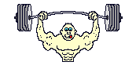
- Two physics students, Will N. Andable and Ben Pumpiniron, are in the weightlifting room. Will lifts the 100-pound barbell over his head 10 times in one minute; Ben lifts the 100-pound barbell over his head 10 times in 10 seconds.
  - Which student does the most work?
  - Which student delivers the most power?
  - Explain your answers.

Power Notes
Power Practice
- A set of pulleys lifts a piano and does 3,356 J of work. If the piano is lifted in 75 s, how much power is used?

- How much work is done in order to cook a bag of popcorn in a 500 W microwave oven for 330 s?
- What is the power of an electric toothbrush if it can do 755.8 J of work in 75 s?
- Sara and Josh do the exact same amount of work. Sara does the work in 2.3 hours and Josh does it in 2.5 hours. Who is more powerful? Explain.
- An athlete is using the row machine in the gym. She generates 350 W of power on the oars in 72 s. What is the work done?

- How long does it take a 75 W light bulb to produce 200,000 J of work?
- How long does it take a 750 W microwave oven to do 1000 J of work?
- A box that weighs 1000 N is lifted a distance of 20 m in 10 s. How many watts of power are produced?
- John is walking to class up the front staircase. He weighs 595 N and the stairs are 3.15 m high. Calculate his power output if he climbs the stairs in 15.2 s.
- A dock worker lifts a 375 N crate a distance of 0.5 m over his head in 2.3 s. What is his power output? (Hint: You must do a calculation before you can begin to solve for power.)

Types of Energy

Potential Energy
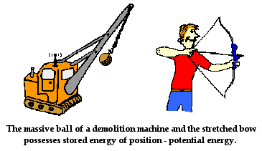
An object can store energy as the result of its position. For example, the heavy ball of a demolition machine is storing energy when it is held at an elevated position. This stored energy of position is referred to as potential energy. Similarly, a drawn bow is able to store energy as the result of its position. When assuming its usual position (i.e., when not drawn), there is no energy stored in the bow. Yet when its position is altered from its usual equilibrium position, the bow is able to store energy by virtue of its position. This stored energy of position is referred to as potential energy. Potential energy is the stored energy of position possessed by an object.

Gravitational Potential Energy
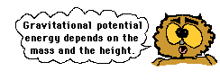
The two examples above illustrate the two forms of potential energy to be discussed in this course - gravitational potential energy and elastic potential energy. Gravitational potential energy is the energy stored in an object as the result of its vertical position or height. The energy is stored as the result of the gravitational attraction of the Earth for the object. The gravitational potential energy of the massive ball of a demolition machine is dependent on two variables - the mass of the ball and the height to which it is raised. There is a direct relation between gravitational potential energy and the mass of an object. More massive objects have greater gravitational potential energy. There is also a direct relation between gravitational potential energy and the height of an object. The higher that an object is elevated, the greater the gravitational potential energy.
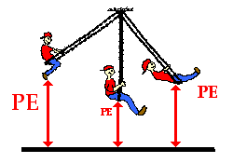
To determine the gravitational potential energy of an object, a zero height position must first be arbitrarily assigned. Typically, the ground is considered to be a position of zero height. But this is merely an arbitrarily assigned position that most people agree upon. Since many of our labs are done on tabletops, it is often customary to assign the tabletop to be the zero height position. Again this is merely arbitrary. If the tabletop is the zero position, then the potential energy of an object is based upon its height relative to the tabletop. For example, a pendulum bob swinging to and from above the tabletop has a potential energy that can be measured based on its height above the tabletop. By measuring the mass of the bob and the height of the bob above the tabletop, the potential energy of the bob can be determined.
Since the gravitational potential energy of an object is directly proportional to its height above the zero position, a doubling of the height will result in a doubling of the gravitational potential energy. A tripling of the height will result in a tripling of the gravitational potential energy.

Elastic Potential Energy
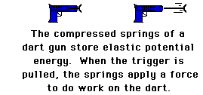
The second form of potential energy that we will discuss is elastic potential energy. Elastic potential energy is the energy stored in elastic materials as the result of their stretching or compressing. Elastic potential energy can be stored in rubber bands, bungee chords, trampolines, springs, an arrow drawn into a bow, etc. The amount of elastic potential energy stored in such a device is related to the amount of stretch of the device - the more stretch, the more stored energy.
If a spring is not stretched or compressed, then there is no elastic potential energy stored in it. The spring is said to be at its equilibrium position. The equilibrium position is the position that the spring naturally assumes when there is no force applied to it. In terms of potential energy, the equilibrium position could be called the zero-potential energy position.
To summarize, potential energy is the energy that is stored in an object due to its position relative to some zero position. An object possesses gravitational potential energy if it is positioned at a height above (or below) the zero height. An object possesses elastic potential energy if it is at a position on an elastic medium other than the equilibrium position.

Reading Comprehension:
- What variables affect gravitational potential energy?
- Why is a zero height position assigned? What is commonly considered to be zero height?
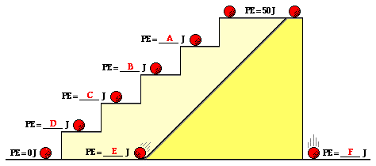
- Use this principle to determine the blanks in the following diagram. Knowing that the potential energy at the top of the tall platform is 50 J, what is the potential energy at the other positions shown on the stair steps and the incline?

- How is elastic potential energy different from gravitational potential energy?

Kinetic Energy
Kinetic energy is the energy of motion. An object that has motion - whether it is vertical or horizontal motion - has kinetic energy. There are many forms of kinetic energy - vibrational (the energy due to vibrational motion), rotational (the energy due to rotational motion), and translational (the energy due to motion from one location to another). To keep matters simple, we will focus upon translational kinetic energy. The amount of translational kinetic energy (from here on, the phrase kinetic energy will refer to translational kinetic energy) that an object has depends upon two variables: the mass (m) of the object and the speed (v) of the object.
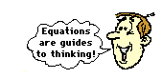
The kinetic energy of an object is directly proportional to the square of its speed. That means that for a twofold increase in speed, the kinetic energy will increase by a factor of four. For a threefold increase in speed, the kinetic energy will increase by a factor of nine. And for a fourfold increase in speed, the kinetic energy will increase by a factor of sixteen. The kinetic energy is dependent upon the square of the speed. As it is often said, an equation is not merely a recipe for algebraic problem solving, but also a guide to thinking about the relationship between quantities.
Kinetic energy is a scalar quantity; it does not have a direction. Unlike velocity, acceleration, force, and momentum, the kinetic energy of an object is completely described by magnitude alone. Like work and potential energy, the standard metric unit of measurement for kinetic energy is the Joule.

Reading Comprehension:
- When does an object have kinetic energy?
- What types of kinetic energy are there?
- How is kinetic energy related to speed?

Mechanical Energy as the Ability to Do Work
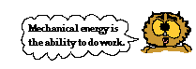
An object that possesses mechanical energy is able to do work. In fact, mechanical energy is often defined as the ability to do work. Any object that possesses mechanical energy - whether it is in the form of potential energy or kinetic energy - is able to do work. That is, its mechanical energy enables that object to apply a force to another object in order to cause it to be displaced.
Numerous examples can be given of how an object with mechanical energy can harness that energy in order to apply a force to cause another object to be displaced. A classic example involves the massive wrecking ball of a demolition machine. The wrecking ball is a massive object that is swung backwards to a high position and allowed to swing forward into building structure or other object in order to demolish it. Upon hitting the structure, the wrecking ball applies a force to it in order to cause the wall of the structure to be displaced. The diagram below depicts the process by which the mechanical energy of a wrecking ball can be used to do work.
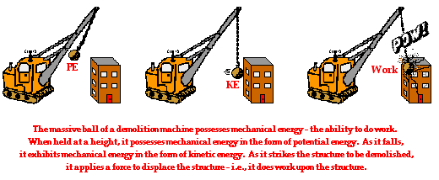

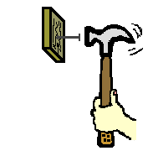
A hammer is a tool that utilizes mechanical energy to do work. The mechanical energy of a hammer gives the hammer its ability to apply a force to a nail in order to cause it to be displaced. Because the hammer has mechanical energy (in the form of kinetic energy), it is able to do work on the nail. Mechanical energy is the ability to do work.

Another example that illustrates how mechanical energy is the ability of an object to do work can be seen any evening at your local bowling alley. The mechanical energy of a bowling ball gives the ball the ability to apply a force to a bowling pin in order to cause it to be displaced. Because the massive ball has mechanical energy (in the form of kinetic energy), it is able to do work on the pin. Mechanical energy is the ability to do work.

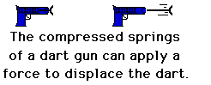
A dart gun is still another example of how mechanical energy of an object can do work on another object. When a dart gun is loaded and the springs are compressed, it possesses mechanical energy. The mechanical energy of the compressed springs gives the springs the ability to apply a force to the dart in order to cause it to be displaced. Because of the springs have mechanical energy (in the form of elastic potential energy), it is able to do work on the dart. Mechanical energy is the ability to do work.
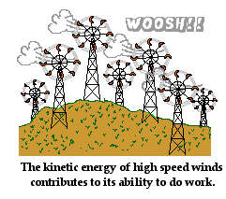
A common scene in some parts of the countryside is a "wind farm." High-speed winds are used to do work on the blades of a turbine at the so-called wind farm. The mechanical energy of the moving air gives the air particles the ability to apply a force and cause a displacement of the blades. As the blades spin, their energy is subsequently converted into electrical energy (a non-mechanical form of energy) and supplied to homes and industries in order to run electrical appliances. Because the moving wind has mechanical energy (in the form of kinetic energy), it is able to do work on the blades. Once more, mechanical energy is the ability to do work.

Total Mechanical Energy
As already mentioned, the mechanical energy of an object can be the result of its motion (i.e., kinetic energy) and/or the result of its stored energy of position (i.e., potential energy). The total amount of mechanical energy is merely the sum of the potential energy and the kinetic energy. This sum is simply referred to as the total mechanical energy (abbreviated TME). TME = PE + KE
The diagram below depicts the motion of Li Ping Phar (esteemed Chinese ski jumper) as she glides down the hill and makes one of her record-setting jumps.
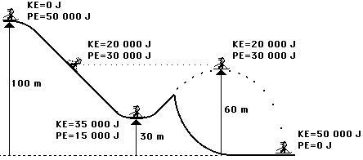
The total mechanical energy of Li Ping Phar is the sum of the potential and kinetic energies. The two forms of energy sum up to 50 000 Joules. Notice also that the total mechanical energy of Li Ping Phar is a constant value throughout her motion. There are conditions under which the total mechanical energy will be a constant value and conditions under which it will be a changing value. Remember that total mechanical energy is the energy possessed by an object due to either its motion or its stored energy of position. The total amount of mechanical energy is merely the sum of these two forms of energy. And finally, an object with mechanical energy is able to do work on another object.
Reading Comprehension:
- An object with mechanical energy has the ability to do _____________.

- What two types of energy are considered mechanical energy?
- Knowing that the total mechanical energy is constant, determine the kinetic and potential energy at the various marked positions along the roller coaster track below. Finally, fill in the bars of the bar charts for positions A, B, C, D, and E.
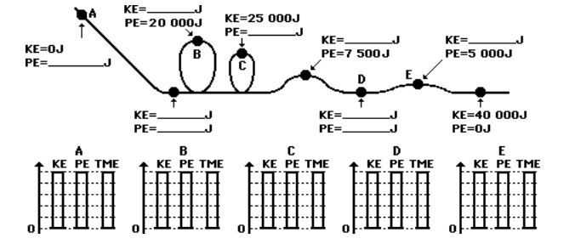

Energy Notes
Types of Energy Notes Pg 2

Identifying Types of Energy Practice
Identify the type(s) of energy in each situation. After you’ve identified the types of energy, indicate whether the amount of energy is constant (=), increasing (↑) or decreasing (↓).
Situation | PE | KE
A car coasting to a stop.
A bicyclist pedaling up a hill
An archer with his bow drawn
The bow drawn by the archer
A volleyball player spiking a ball
The ball being spiked by the player
A baseball thrown to second base
A person walking down the street
A cat sitting in the top of a tree
A bowling ball rolling down the alley
A bowling ball sitting on the rack

Types of Energy Practice
- Determine the kinetic energy of a 1000-kg roller coaster car that is moving with a speed of 20.0 m/s.

- A platform diver had a kinetic energy of 15,000 J just prior to hitting the bucket of water. If her mass is 50 kg, then what is her speed?
- A cart is loaded with a brick and pulled at constant speed along an inclined plane to the height of a seat-top. If the mass of the loaded cart is 3.0 kg and the height of the seat top is 0.45 meters, then what is the potential energy of the loaded cart at the height of the seat-top?
- The potential energy of a 40-kg cannon ball is 14000 J. How high was the cannon ball to have this much potential energy?
- A rollercoaster has 130,000 J of kinetic energy and 450,000 of potential energy. What is the total mechanical energy?

- If the roller coaster car problem #1 were moving with twice the speed, then what would be its new kinetic energy?

- A hockey puck with a mass of 0.2 kg has 5,000 J of kinetic energy. What is the speed of the puck?
- A 75-kg refrigerator is located on the 70th floor of a skyscraper (300 meters above the ground) What is the potential energy of the refrigerator? A pendulum has 3,500 J of potential energy. If it has a mass of 2 kg, how high is it?
- A pendulum has 3,500 J of potential energy. If it has a mass of 2 kg, how high is it?
- A 70 kg skier is skiing down a mountain at 35 m/s. If she is 125 m from the bottom, what is her total mechanical energy?
Conservation of Energy Notes

Conservation of Energy Practice
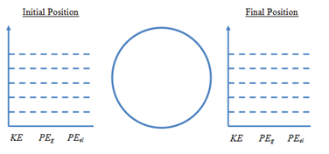
- A freight train with a mass of 1.8 x 10⁷ is traveling at 28 m/s. The freight train’s brakes stop working, and it hits a huge, coiled piece of metal at the end of the rails, that serves as an emergency ‘shock absorber’ for the train. It manages to safely bring the train to a stop. If the coiled piece of metal has a K value of 400,000 N/m, how far was it compressed?

- A 450 kg rollercoaster car is stationary at the start of the rollercoaster track, 150 m in the air. If the roller coaster is moving at 45 m/s, how high is it from the ground?

- A 450 kg rollercoaster car is stationary at the start of the rollercoaster track, 150 m in the air. When the rollercoaster car is moving on the piece of track that’s on the ground, what is its velocity at that point?

- A 450 kg rollercoaster car is stationary at the start of the rollercoaster track, 150 m in the air. What is the velocity of the roller coaster at 60 m?

- A 0.05 kg popup toy has a spring that is compressed, and that launches the toy into the air once you let go. If the spring constant for the spring is .2 N/m, and you compress it by 0.05 m, how high will it be at the top of its trajectory?

- A 0.05 kg popup toy has a spring that is compressed, and that launches the toy into the air once you let go. If the spring constant for the spring is .2 N/m, and you compress it by 0.05 m, how fast is it going when it leaves the spring?

- A high jumper is running at 5 m/s. How high of a bar will she be able to clear? Assume that all of her kinetic energy becomes potential energy when she clears the bar.

- A 2000 kg car rolls down a hill. If the hill was 30 m high, and friction does 200,000 J of work, how fast is the car moving at the bottom of the hill?

- A 5 kg skateboard is rolling at 4 m/s on flat ground. How high will it roll up a hill?
- A cat is standing still on a windowsill. He then begins falling. When he is still 4.6 m above the ground, he is moving at 7.2 m/s. How high was the windowsill?

- A person throws a ball starting at 1.3 m high upwards. When the ball reaches its highest point, it is 6.2 m above the ground. How fast was the ball thrown?

- A squirrel jumps from a 2.8 m tall tree at 2 m/s. At what height before hitting the ground is the squirrel moving at 5m/s?

Work-Energy Theorem Notes
Work-Energy Practice
- A football player slows an 85 kg opponent down from 6 m/s to 2 m/s. How much work is done on the opponent?

- A football player slows a 95 kg opponent who is running at 9 m/s. If the work done on the opponent is -2500 J, what is the final speed of the opponent?

- A football player slows a 73 kg opponent down to 3 m/s. If the work done on the opponent is -2000 J, what was the opponent’s initial speed?
- A falling 4.6 kg bowling ball speeds up from 3 m/s to 7 m/s. What is the work done by gravity on the bowling ball?

- A 200 kg train car is traveling at 18 m/s. How much work must the brakes do on the train to stop it?

- A falling 3.7 kg bowling ball is going 9 m/s. If the work done by gravity is 130 J, what is the final speed of the bowling ball?

- A 250 kg train car slows down from 20 m/s. If the brakes do -34000 J of work on the train, what is the final speed of the train?

- A falling 3.9 kg bowling ball speeds up to 13 m/s. If the work done by gravity was 312 J, what was the initial speed of the bowling ball?

- A 225 kg train car slows down to 22 m/s. If the brakes did -47,000 J of work on the train, what was the train’s initial speed?A 32 kg child is sitting still at the top of a slide that is 4.7 m tall. At the bottom of the slide, the child is moving at 7 m/s. How much work was done by friction to slow the child down?

- A 5 kg skateboard is rolling at 4 m/s on flat ground. If friction does 10 J of work, how high will it roll up a hill?

- You can only apply a 200 N force but you need to make a 20 kg wagon of mulch travel at a speed of 10 m/s. how far do you have to push the wagon before its speed reaches 10 m/.s if it starts from rest? You may assume no friction.

- A toy car with mass of 2 kg starts at rest. A spring performs 196 Joules of work on the car. What is the toy car’s final velocity?

Work, Power and Energy Test Review
Complete the quantity chart:
Quantity | Variable  (symbol in formula) | Unit | Unit Symbol
 |  | meters
time
 |  |  | kg
 |  | meters per second
Force
Work

 |  |  | W
 | KE
 | PE

- For the following scenarios, answer the question: is work being done? Why or why not?
  - A cat slides into the wall. Is work being done? Why or why not?
  - A mover carries a box down the hall. Is work being done? Why or why not?
  - You lift a box off the ground. Is work being done? Why or why not?
- A rock climber applies a force of 150 N to scale a cliff 200 m tall. How much work was done?
- If the climb took 20 minutes, how much power did the rock climber use? Don’t forget to convert minutes to seconds.
- A squirrel does 78 J of work climbing 10 m to stash his acorns for the winter. How much force did he apply?
- What is the amount of work that a 60-Watt light bulb does in 20 seconds?
- Two people complete the same identical task. If person A completes it in 20 seconds, while person B completes it in 40 seconds, how does the work done by each compare? How does the power developed compare?
- A force of 230 Newtons is used to move a desk 5 meters in 35 seconds. How much power was generated?
- A 0.17 kilogram hockey puck is gliding along at 5 m/s. How much work must be done to increase its velocity to 10 m/s?
- A 1000 Joules of work is done lifting a 90 kilogram crate vertically. What height was the crate lifted to?
- A child does work to compress a spring pop up toy.
  - Before the toy is released, what form is all of the energy stored in?
  - Immediately after the toy is released, what form is all of the energy in?
  - When the toy reaches the apex of its flight, what form is all of the energy stored in?
- A 3,500 kilogram elephant is stampeding at 5 m/s. What is the elephant’s average kinetic energy?
- How does a pendulum’s potential energy change as it swings down? As it swings back up?
- A 1.3 kilogram hawk has 3,400 Joules of potential energy. How high above the ground is he flying?
- A ball is thrown upward. How does its kinetic energy change as it rises? How does its potential energy change as it rises?
- If the velocity of a moving object is tripled, how does the kinetic energy change?
- The work energy theorem states that the amount of work done is equal to ___________________.
- A 0.5 N flying squirrel glides down from a height of 20 meters. If 4 Joules of energy are lost to air resistance, what is the maximum kinetic energy of the squirrel at the end of his glide?
- A spring with a spring constant of 70 N/m is compressed with 1000 Joules of work. How far was the spring compressed?
- A zamboni applies a 750 N force to a 50 kilogram block of ice over a distance of 1 meter. What is the ice blocks new velocity? Assume there is no friction.
- A trampoline has a spring constant of 200 N/m. If a 25 kilogram child compresses the springs 0.2 meters, what is the maximum height the child will reach? Assume all elastic potential energy is converted into gravitational potential energy

