AP PHYSICS 1 MOMENTUM EXAM REVIEW
NAME__________________________________________ DATE_________________________

1. Two objects, P and Q, have the same momentum. Q can have more kinetic energy than P if it has:
(A) More mass than P (B) The same mass as P (C) More speed than P (D) The same speed at P

2. Two carts are held together. Cart 1 is more massive than Cart 2. As they are forced apart by a compressed
spring between them, which of the following will have the same magnitude for both carts.
(A) change of velocity (B) force (C) speed (D) velocity

3. A cart with mass 2m has a velocity v before it strikes another cart of mass 3m at rest. The two carts couple and
move off together with a velocity of
(A) v/5 (B) 2v/5 (C) 2v/3 (D) (2/5)1/2 v

4. A student initially at rest on a frictionless frozen pond throws a 1 kg hammer in one direction. After the throw,
the hammer moves off in one direction while the student moves off in the other direction. Which of the following correctly describes the above situation?
- The hammer will have the momentum with the greater magnitude
- The student will have the momentum with the greater magnitude
- The hammer will have the greater kinetic energy
- The student will have the greater kinetic energy

5. Two toy cars with different masses originally at rest are pushed apart by a spring between them. Which TWO
of the following statements would be true?
- both toy cars will acquire equal but opposite momenta
- both toy cars will acquire equal kinetic energies
- the more massive toy car will acquire the least speed
- the smaller toy car will experience an acceleration of the greatest magnitude

6. Two bodies of masses 5 and 7 kilograms are initially at rest on a horizontal frictionless surface. A light spring
is compressed between the bodies, which are held together by a thin thread. After the spring is released by burning through the thread, the 5 kilogram body has a speed of 0.2 m/s. The speed of the 7 kilogram body is
(in m/s)

- 1/12 (B) 1/7 (C) 1/5 (D) 1/(35)^{0.5}

7. A solid metal ball and a hollow plastic ball of the same external radius are released from rest in a large vacuum
chamber. When each has fallen 1 meter, they both have the same

(A) inertia (B) speed (C) momentum (D) change in potential energy

8. A railroad car of mass m is moving at speed v when it collides with a second railroad car of mass M which is at
rest. The two cars lock together instantaneously and move along the track. What is the kinetic energy of the cars immediately after the collision?
(A) ½ mv2 (B) ½ (M+m)(mv/M)2 (C) ½ (M+m)(Mv/m)2 (D) ½ (M+m)(mv/(m+M))2

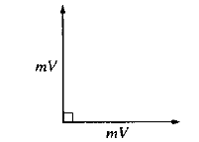

9.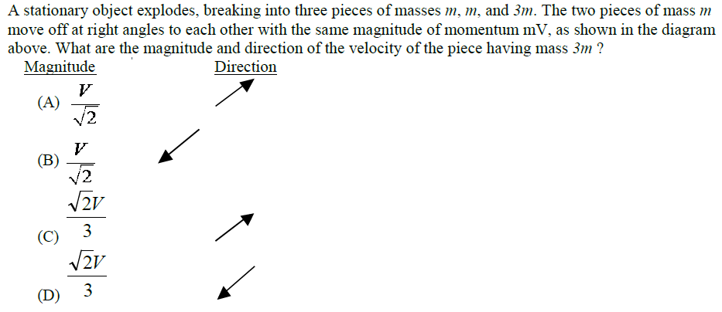

10.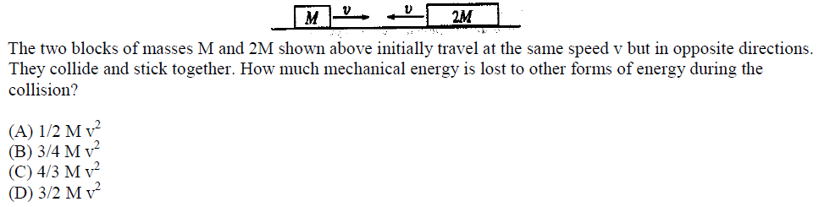

11.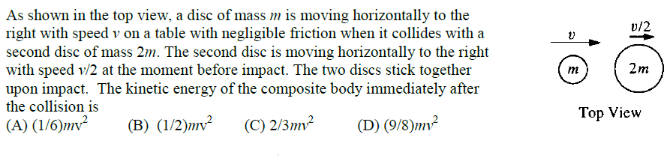

12. 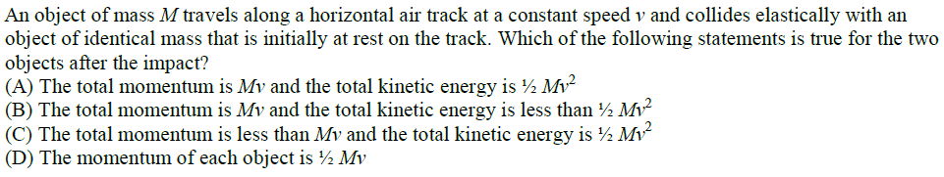

13. A 80-kg sled is moving with negligible friction to the left at 7 m/s on a horizontal surface. A 20 kg person drops onto the sled. Determine the speed of the sled after the person drops onto it.

FREE RESPONSE
