Conservation of Energy Roller Coaster Lab
Question: What is energy and how does it behave?
In this investigation, you will:
- Discover the relationship between speed and height on a roller coaster.
- Describe how energy is conserved on a roller coaster.
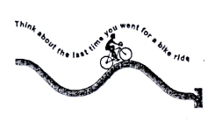
To pedal your bike up a hill, you have to work hard to keep the bike going. However, when you start down the other side of the hill, you coast! You hardly have to pedal at all. In this Investigation, you will find out what happens to the speed of the marble as it rolls up and down the hills and valleys of the CPO roller coaster.

- Setting up the roller coaster
Attach the roller coaster to the fifth hole from the bottom of the stand. Use the starting peg to start the marble in the same place each time you roll it down. It sometimes takes a few tries to roll is straight so that it stays on the track. Watch the marble roll along the track. At which place (or places) do you think the marble moves the fastest. Why?
Explanation:
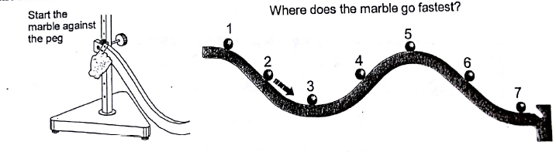

- Measuring the speed of the marble
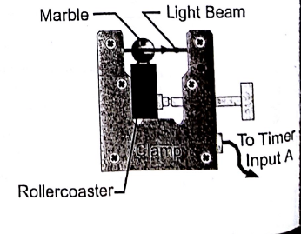
To understand what is happening to the marble, you need to measure the speed and the height at different places on the roller coaster.
- To measure the speed of the marble, attach a photogate so that the marble breaks the light beam as it rolls through.
- Plug the photogate into the input A of the timer and use interval mode.
- Be sure that the bottom of the photogate is flat against the bottom of the roller coaster. If the photogate is not attached properly, the light beam will not cross the center of the marble and the speed you calculate will not be accurate.
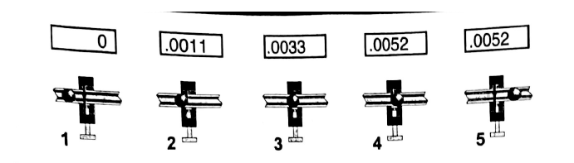
- The ball has not broken the beam yet. The timer is not counting.
- The timer starts counting when the front edge of the marble breaks the beam.
- The timer keeps counting while the beam is blocked by the marble.
- The timer stops counting when the back edge of the marble goes out of the beam.
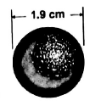
- The display shows the time that the marble blocked the beam.
Speed is the distance traveled divided by the time taken to travel that distance. During the time that the timer is counting, the marble moves one diameter. Therefore, the distance traveled is the diameter of the marble, and the time taken is the time from photogate A. The speed of the marble is its diameter divided by the time from photogate A.
Use the photogate to test your hypothesis about where the marble would go the fastest. Measure the speed and record the speed of the marble at each of the seven places. Positions 2, 4, and 6 should be as close to the same height as your can get. If they are the same height, you can easily compare uphill and downhill motion.
Position number | Time, photogate A  (sec) | Distance traveled  (cm) | Speed of marble  (cm/sec)
1 |  | 1.9
2 |  | 1.9
3 |  | 1.9
4 |  | 1.9
5 |  | 1.9
6 |  | 1.9
7 |  | 1.9
Paragraph #1 in your journal: Respond to the following questions.
- Did your measurements agree with your hypothesis or did they point to a different hypothesis? If the answer did not agree with your hypothesis, what sort of hypothesis do the observations support about where the marble is the fastest?
- What did you notice about the motion of the marble from the measurements? For example, do you think that going uphill or downhill makes a difference in the speed? Does height affect speed? Which has a larger impact, height or direction (uphill or downhill)
- Energy Conservation
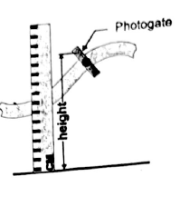
When the marble speeds up, it is gaining kinetic energy from falling down a hill. The kinetic energy is converted from the potential energy the marble had at the top of the hill. As the marble goes along, it trades potential and kinetic energy back and forth.
To measure the kinetic energy, we use the photogate to find the speed of the marble. To get the potential energy, we need to measure the height. The light beam passes through the center of the marble, so you should measure the height from the table to the center of the hole for the light beam.
For the positions close to the start, you will have to measure from the base of the stand. Add the height of the base to the height you measure to get the total height.
- Place the photogate at different places along the roller coaster.
Measure the speed and the height of the marble at each place.
- Write your data down in the table below.
Position  (cm) | Height  (cm) | Time from Photogate A  (sec) | Distance Traveled  (cm) | Speed of Marble  (cm/sec)
 |  |  | 1.9
 |  |  | 1.9
 |  |  | 1.9
 |  |  | 1.9
 |  |  | 1.9
 |  |  | 1.9
 |  |  | 1.9
 |  |  | 1.9
 |  |  | 1.9
 |  |  | 1.9
 |  |  | 1.9
 |  |  | 1.9

- Graphing Height vs. Speed
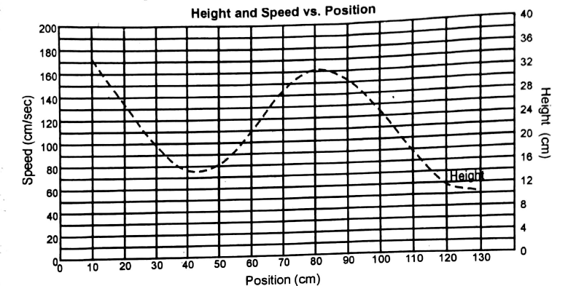
Take your measurements and make a graph that shows the relationship between height and speed. The graph provided already shows the height of the roller coaster plotted against the position along the track. Plot the speed vs. position on the same graph.

Paragraph #2 in your journal: Respond to the following questions.
- What can you tell from your graph? Describe the relationship you see between the speed of the marble and the height.
- Where is the speed of the marble greatest?
- Does the uphill or downhill direction matter to the speed of the marble, or is the height the only contributing variable?
- Describe the flow of energy between potential and kinetic along the roller coaster. Your answer should indicate where the potential energy is greatest and least, and also where the kinetic energy is greatest and least.

