Name _____________________________________________Date_________________________Per___
TORQUE Practice Problems
- A window washer is standing on a scaffold supported by a vertical rope at each end. The scaffold weighs 205 N and is 3.00 m long. What is the force each rope exerts on the scaffold when the 675 N worker stands 1.00 m from one end of the scaffold? Sketch a diagram.
- A floodlight with a mass of 20.0 kg is used to illuminate the parking lot in front of a library. The floodlight is supported at the end of a horizontal beam that is hinged to a vertical pole, as shown in the figure. A cable that makes an angle of 30.0º with the beam is attached to the pole to help support the floodlight. Find the following, assuming the mass of the beam is negligible when compared with the mass of the floodlight:
- the force provided by the cable
30º

- the horizontal and vertical forces exerted on the beam by the pol

- For a rigid body to remain in equilibrium, it is necessary and sufficient that
- ∑ F = 0
- ∑ I σ= 0
- ∑  = 0
- ∑  = 0, ∑ F = 0

- The horizontal bar in the figure will remain horizontal if
- L₁ = L₂ and R₁ = R₂ R₁ R₂
- L₁ = L₂ and M₁ = M₂
- R₁ = R₂ and M₁ = M₂ L₁ L₂
- L₁M₁ = L₂M₂
- R₁L₁ = R₂L₂ M₁ M₂

- Daniel and Jonathan are playing on the seesaw with their mother in the park. The 6 –m long uniform board is hinged at its midpoint. If Daniel and Jonathan weigh 30 kg and 20 kg and sit at distances of 2 m and 3m respectively from the fulcrum, calculate where their mother (mass = 60 kg) has to sit on the other side of the fulcrum for static equilibrium.
- 2.5 m
- 1.5 m
- 1.0 m
- 2.0 m

- Find the torque by each force exerted on the figure below. B. Find the magnitude and direction of the force that must be exerted at the right end, perpendicular the rod, to maintain rotational equilibrium. (the pivot point is at the far left hand side)
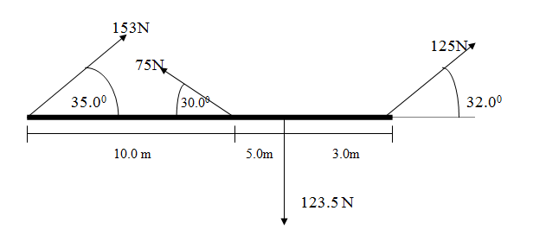

- A 10m, 65kg boom extends horizontally from a wall and has a 50kg mass hanging from it 7.5m from the wall.
            - Find the tension in the cable.
            - Find the vertical force at the wall.
            - Find the horizontal force at the wall.

22⁰
50kg

